**CHAPTER 2**

**LITERATURE REWIEW**

An elevator is a type of vertical transportation that moves people or good between floors, level or decker of a building and other structures. They are normally powered by electric motor that pull cables along pulleys. In agriculture and manufacturing, an elevator is any type of conveyor device used to lift materials.

**2.1. History of Elevator**

The first reference to an elevator is in the works of the Roman architect Vitruvius, who reported that Archimedes built his first elevator probably in 236 BC. In the seventh century, the prototypes of elevator were located in the palace buildings of England and France. The elevator was first developed during the 1800s and relied on steam or hydraulic plungers for lifting capability. In the latter application, the cab was affixed to a hollow plunger that lowered into an underground cylinder Liquid, most commonly water, was injected into the cylinder to create pressure and make the plunger elevate the cab, which would simply lower by gravity as the water was removed. Valves governing the water flow were manipulated by passengers using ropes running the cab, a system later enhanced with the incorporation of lever controls and pilot valves to regulate cab speed. The traction elevators first appeared during the ninth century in the U.K, a lift using a rope running through a pulley and a counterweight tracking along the shaft wall.

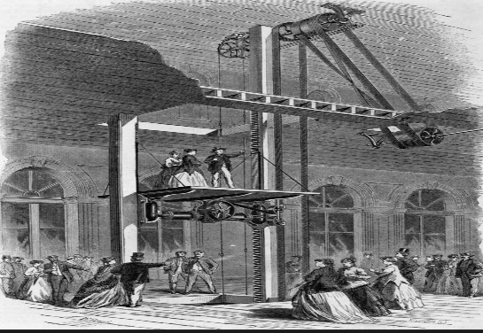

Figure 2.1. Steam Driven Elevator in the 1800s

The power elevator debuted mid-19th century in the U.S. as a simple freight hoist operating between just two floors in a New York City building. By 1853, Elisha Graves Otis was at the New York Crystal Palace exposition, demonstrating an elevator with a "safety" to break the cab's fall in case of rope failure, a defining moment in elevator development. By 1857, the country's first Otis passenger elevator was in operation at a New York City department store, and, ten years later, Elisha's sons went on to achieve mass production of elevators. Various other elevator designs appeared on the landscape, including screw-driven and rope-geared, hydraulic models.

Later in the 1800s, with the advent of electricity, the electric motor was integrated into elevator technology by German inventor Werner von Siemens. With the motor mounted at the bottom of the cab, this design employed a gearing scheme to climb shaft walls fitted with racks. In 1887, an electric elevator was developed in using a revolving drum to wind the hoisting rope, but these drums could not practically be made large enough to store the long hoisting ropes that would be required by skyscrapers.

Motor technology and control methods evolved rapidly. In 1889 came the direct-connected geared electric elevator, allowing for the building of significantly taller structures. By 1903, this design had evolved into the gearless traction electric elevator, allowing hundred-plus story buildings to become possible and forever changing the urban landscape. Multi-speed motors replaced the original single-speed models to help with landing-leveling and smoother overall operation. Electromagnet technology replaced manual rope-driven switching and braking. Pushbutton controls and various complex signal systems modernized the elevator even further. Safety improvements have been continual, including a notable development by Charles Otis- son of original "safety" inventor Elisha- that engaged the "safety" at any excessive speed, even if the hoisting rope remained intact.

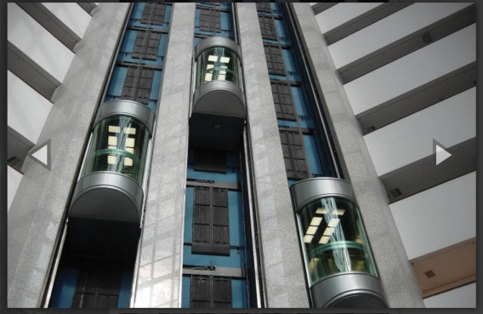

Figure 2.2. Today’s Elevator

Today, there are intricate governors and switching schemes to carefully control cab speeds in any situation. "Buttons" have been giving way to keypads. Virtually all commercial elevators operate automatically and the computer age has brought the microchip-based capability to operate vast banks of elevators with precise scheduling, maximized efficiency and extreme safety.

**2.2.** **Different Types of Elevator**

There are four major elevator designs in common use today. They are:

* Hydraulic Elevators
* Roped Elevator
* Traction Elevator
* Traction Hydraulic Elevator

2.2.1. Hydraulic Elevator

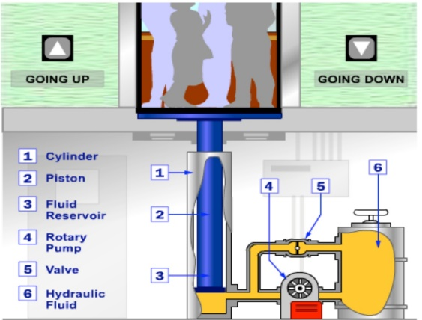

Figure 2.3. Hydraulic Elevator

These elevator control systems lift a car using a hydraulic ram, a fluid driven piston mounted inside a cylinder. The cylinder is connected to a fluid pumping system typically, the hydraulic systems like this use oil but other incompressible fluids are also work. The hydraulic system has three parts.

* A tank or the fluid reservoir
* A pump powered by electric motor
* A valve between the cylinder and the reservoir

The basic components of hydraulic elevator are:

* Piston
* Hydraulic Fluid
* Cylinder
* Valve
* Rotary Pump
* Reservoir

The pump forces fluid from the tank into a pipe leading to the cylinder. When the valve is opened, the pressurized fluid will take the path of least resistance and return to the fluid reservoir. But when the valve is closed, the pressurized fluid has nowhere to go except into the cylinder. As the fluid collects in the cylinder, it pushes the piston up, lifting the elevator car. When the car approaches the correct floor, the control system sends a signal to the electric motor to gradually shut off the pump. With the pump off, there is no more fluid flowing into the cylinder, but the fluid that is already in the cylinder cannot escape (it can't flow backward through the pump, and the valve is still closed). The piston rests on the fluid, and the car stays where it is. To lower the car, the elevator control system sends a signal to the valve. The valve is operated electrically by a basic solenoid switch (Solenoid switches are used to switch high power circuits on and off using a much smaller electrical control signal to actuate the switching). When the solenoid opens the valve, the fluid that has collected in the cylinder can flow out into the fluid reservoir. The weight of the car and the cargo pushes down on the piston, which drives the fluid into the reservoir. The car gradually descends. To stop the car at a lower floor, the control system closes the valve again. The main advantage of hydraulic systems is they can easily multiply the relatively weak force of the pump to generate the stronger force needed to lift the elevator car.

2.2.2. Roped Elevator

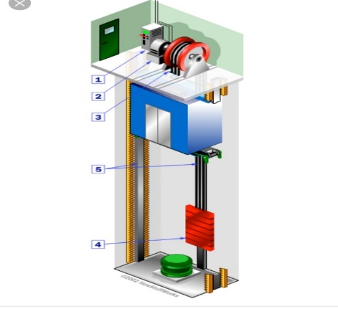

Figure 2.4. Roped Elevator

In roped elevators, the car is raised and lowered by traction steel ropes rather than pushed from below. The ropes are attached to the elevator car, and looped around a sheave. A sheave is just a pulley with grooves around the circumference. The sheave grips the hoist ropes, so when the sheave rotates, the ropes move too. The sheave is connected to an electric motor. When the motor turns one way, the sheave raises the elevator; when the motor turns the other way, the sheave lowers the elevator. In gearless elevators, the motor rotates the sheaves directly. In geared elevators, the motor turns a gear train that rotates the sheave. Typically, the sheave, the motor and the control system are all housed in a machine room above the elevator shaft.

The basic components of a rope elevator system are:

* Control system
* Electric motors
* Sheave
* Counterweight
* Guide rails

The ropes that lift the car are also connected to a counterweight, which hangs on the other side of the sheave. The counterweight weighs about the same as the car filled to 40-percent capacity. In other words, when the car is 40 percent full (an average amount), the counterweight and the car are perfectly balanced. The purpose of this balance is to conserve energy. With equal loads on each side of the sheave, it only takes a little bit of force to tip the balance one way or the other. Basically, the motor only has to overcome friction the weight on the other side does most of the work. To put it another way, the balance maintains a near constant potential energy level in the system as a whole. Using up the potential energy in the elevator car (letting it descend to the ground) builds up the potential energy in the weight (the weight rises to the top of the shaft). The same thing happens in reverse when the elevator goes up. Both the elevator car and the counterweight ride on guide rails along the sides of the elevator shaft. The rails keep the car and counterweight from swaying back and forth, and they also work with the safety system to stop the car in an emergency. Rope elevator are much more versatile than hydraulic elevators, as well as more efficient. Typically, they also have more safety systems.

2.2.3. Traction Elevator

These elevators have steel ropes that raise and fall cars from above. In a machine room above the elevator shaft, a control system operates a motor that turns sheave. Cables roll over this deeply grooved pulley to pull a car up or lower it down. The cables are also attached to a counterweight that weighs about as much as the car on the other side of the sheave when it is at 40% of capacity purpose of the counterweight is to create a balance to conserve energy. The motor can move the car by just over coming friction between the ropes and sheave and the difference in weight between the elevator car and the counterweight.

Almost all modern electric elevators are the traction of type. The elevator car is raised and lowered by a hoisting machine which rotates a grooved sheave over which the hoisting cable pass, the necessary traction being obtained by the fraction between these cables and the grooved surfaces of the sheave and the pressure being applied by the weight of the elevator car and it load, the counterweight and the weight of the cables. In the former, DC or synchronous motors were used for the traction elevators.

But new installation use AC motor and Variable Voltage and Variable Frequency (VVVF) for speed control. The two types of traction elevators are;

* Gearless traction elevator
* Gear traction elevator

2.2.3.1. Gearless Traction Elevator

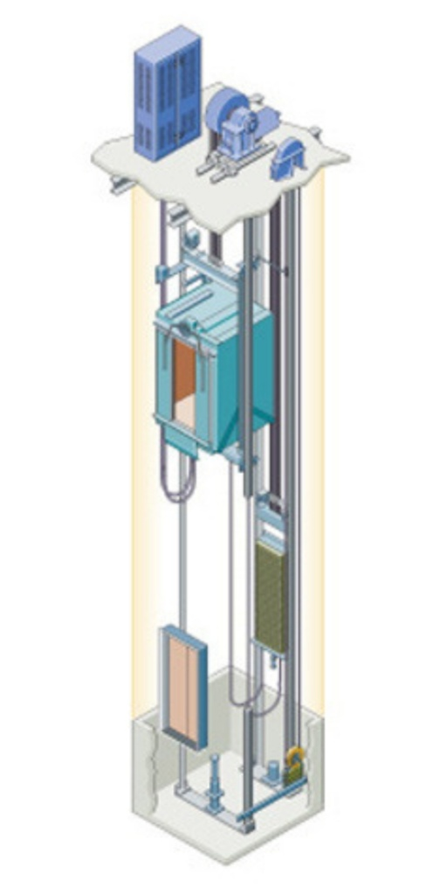

Figure 2.5. Gearless Traction Elevator

Gearless traction elevators are used for high rise buildings, where medium and high speed (400 fpm and above) are required. A gearless traction elevator machine consists of a DC motor, the shaft of which is directly connected to the wheel and the driving sheave. The absence of gears means that the motor must run at the same relatively speed as the driving shave. Gearless traction elevators are generally utilized for passenger service, with usual car capacities of 2000 to 4000 lb. There are only two bearings that carry the total rope pull due to car and counterweight.

2.2.3.2. Geared Traction Elevator

Geared traction machine are driven by AC or DC electric motor. Therefore, the driven motor can be a smaller and cheaper high speed unit. The motor shaft may be AC and new installations, whereas the gearless unit is always DC. Prior to the development of a solid state, thyristor controlled AC drive, AC motor where applicable to rheostatic control. Some years ago, smooth operation and higher speeds required the use of a motor generator set to drive a DC motor. However, many of the major manufacture use the geared traction elevators for installation up to 350 fpm with thyristor or Variable Voltage and Variable Frequency (VVVF) control.

Dump waiters are generally driven by a small electric motor with a counterweight and their capacity is about 750lb (340kg). It is used in hotels and restaurants for service from the kitchens to the dining rooms and may also be used as book lift in libraries. The speed of travel is invariably between 50 fpm and 150 fpm.

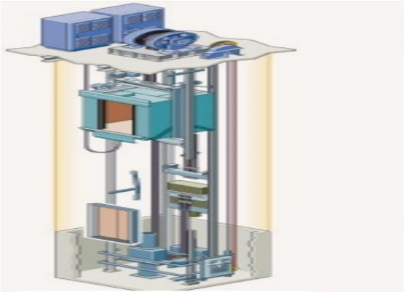

Figure 2.6. Geared Traction Machine

2.2.4. Traction Hydraulic Elevator

The traction hydraulic elevator has overhead traction cable and counterweight, but is driven by hydraulic power instead of an overhead traction motor. The weight of the car and its passenger, plus an advantageous roping ratio, reduces the demand from the pump to raise the counterweight, thereby reducing the size of the required machinery. The great development of variable speed driver made most widely used type in traction elevators, also its advantage of energy saving managed it to become favorable.

**2.3**. **Safety System**

Elevators are built with several redundant safety systems that keep them in position. The first line of defense is the rope system itself. Each elevator rope is made from several lengths of steel material wound around one another. But elevators are built with multiple ropes. The elevator ropes make to strength. The elevator car is also installed the door system. A lift is used to transport passengers, so the most important is the safety of the lift. The safety of the lift is closely linked to design, manufacturing, installation, commissioning and maintenance process. Some parts have problems and it causes safety risks or even some big accidents. So, the elevator installer firstly priority the safety in everywhere.

**2.4. Types of Arduino**

There are mainly four types of Arduino:

* Pad UNO
* MEGA
* Lily Pad
* NANO

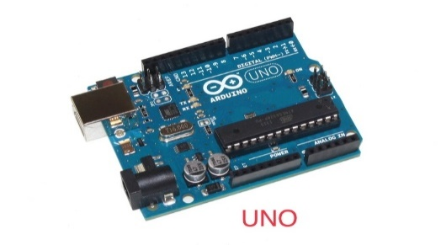2.4.1. Arduino UNO

Figure 2.7. Arduino UNO

Arduino UNO is a microcontroller board based on the ATmega328P. It has 14 digital input/output pins (of which 6 can be used as PWM outputs), 6 analog inputs, a 16 MHz quartz crystal, a USB connection, a power jack, an ICSP header and a reset button. It contains everything needed to support the microcontroller; simply connect it to a computer with a USB cable or power it with a AC- to-DC adapter or battery to get started. It can tinker with the UNO without warring too much about doing something wrong, worst case scenario it can replaced the chip for a few dollars and start over again.

“UNO” means one in Italian and was chosen to mark the release of Arduino Software (IDE) 1.0. The UNO board and version 1.0 of Arduino Software were the reference versions of Arduino, now evolved to newer releases. The UNO board is the first in a series of USB Arduino boards, and the reference model for the Arduino platform.

2.4.2. Arduino MEGA

Arduino Mega is a microcontroller board based on the ATMEGA. It has 54 digital input/output pins ,16 analog inputs, 4 UARTs, a16MHZ crystal oscillator, a USB connection, a power jack, an ICSP header, and a reset button. It contains everything needed to support the microcontroller; simply connect it to a computer with a USB cable or power it with a AC-to-DC adapter or battery to get started. The Mega board is compatible with most shields designed for the UNO and the former boards Duemilanove or Diecimila.

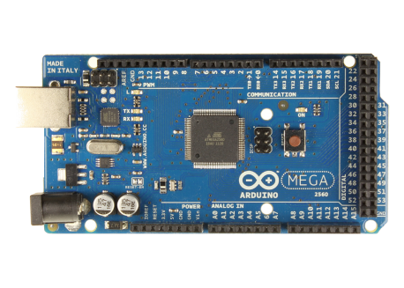

Figure 2.8. Arduino Mega

2.4.3. Arduino Lily Pad

The Lily Pad Arduino is a microcontroller board designed for wearable and e-textiles. It can be sewn to fabric and similarly mounted power supplies, sensors and actuators with conductive thread. The board is based on the AT mega 168V (the low-power version of the AT mega 168) or the AT mega 328V. The Lily Pad Arduino was designed and developed by Leah Buechiey and SparkFun Electronics.

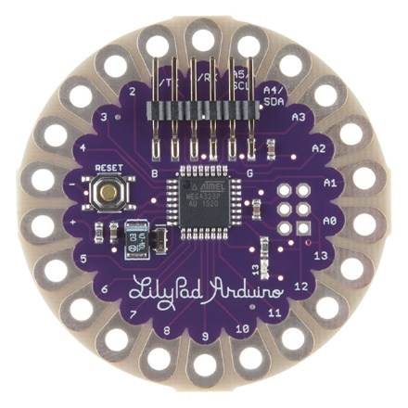

Figure 2.9. Arduino Lily Pad

2.4.4. Arduino NANO

Arduino NANO is a small, complete, and breadboard-friendly board based on the AT mega 328P (Arduino NANO 3.x). It has more or less the same functionality of the Arduino Duemilanove, but in a different package. It lacks only a DC power jack, and works with a Mini-B USB cable instead of a standard 1.

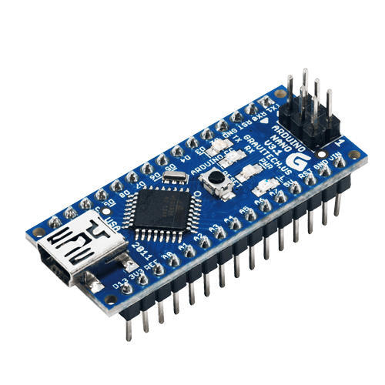

Figure 2.10. Arduino NANO

**2.5. Types of Stepper Motor**

There are four types of stepper motors.

* Permanent Magnet Stepper Motor
* Hybrid Synchronous Stepper Motor
* Variable Reluctance(VR) Stepper Motor
* Livet Type Stepper Motor

2.5.1. Permanent Magnet Stepper Motor

This can be divided into ‘tin can’ and ‘hybrid’. Tin can be a cheaper product and hybrid with higher quality bearings, smaller step angles, high power density. PM motors use a permanent magnet in the rotor and operate on the principle of attraction or repulsion between rotor PM and stator electromagnets.

2.5.2. Hybrid Synchronous Stepper Motor

They use a combination of PM and VR characteristics to achieve maximum power in a small package size.

2.5.3. Variable Reluctance(VR) Stepper Motor

They operate on the principle that minimum reluctance occurs with minimum gap, hence the rotor points are attracted towards the stator magnetic poles. Here, the

excitation of stator phases gives rise to a torque in a direction which minimizes the magnet circuit reluctance. They can be single stack or multi-stack motors.

2.5.4. Livet Type Stepper Motor

The two basic winding arrangement for electromagnetic coils in a two phase stepper motor can be used to classify this motors into

* Unipolar stepper motors
* Bipolar stepper motors

2.5.4.1. Unipolar Stepper Motor

This motor has two windings per phase, one for each direction of magnetic field i.e. one winding with a center tap per phase. Each section of windings is switched on for each direction of magnetic field. Magnetic pole can be reversed here without switching the direction of the current and hence the commutation circuit can be made very simple for each winding. Typically, given a phase, one end of each winding is made common: giving three leads per phase and thus six leads for a two phase motor.

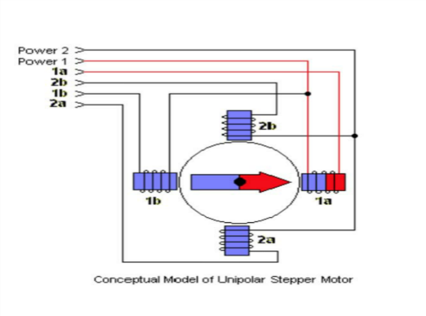

Figure 2.11. Unipolar Stepper Motor

.

2.5.4.2. Bipolar Stepper Motor

Bipolar motors have a single winding per phase. The current in a winding needs to be reversed in order to reverse a magnetic pole, thus the driving circuit must be more complicated; typically, with an H-bridge arrangement (however there are several off the shelve drive chips that simplify this). There are two leads per phase, non are common. The static friction effects using an H-bridge have been observed with certain drive topologies. Since the windings are better utilized, they are powerful compared to unipolar motors of the same weight. This is due to the physical space occupied by the windings. A unipolar stepper motor has twice the amount of wires in the same space but with only half of them used at any point in time thus is 50% efficient with only around 70% output torque available. Though bipolar one is more complicated to drive, it’s more efficient since the drive chips are abundance and easy to achieve.

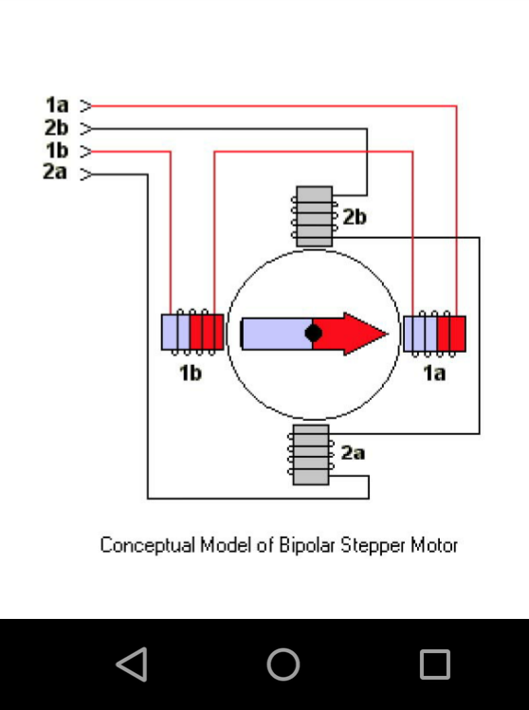

Figure 2.12. Bipolar Stepper Motor